Setup the Development Environment

Open the Solution: \

"C:\_Work\Development\ANZLIC\ArcGIS Metadata Toolkit 10_SP3\CustomMetadataEditor Source\CustomMetadataEditor.sln"

ONLY Visual Studio 2010

Build

Build should create and copy the files to the Application Target location

The Solutions Folder structure should look this

<ArcGIS Desktop Install Location\>

|  |  |  |  |  |
| --- | --- | --- | --- | --- |
| Ref NR | Folder | Sub Folder | File(s) |  |
| 1 | Bin |  | EsriAu.ANZLIC.Metadata.Editor.dll |  |
| 1.1 | Bin | ANZLIC_Settings | ANZLIC_Defaults.xml  ANZLIC_Settings.xml  Example Shared ANZLIC Settins.xml |  |
|  |  |  |  |  |
| 1.2 | Bin | Icons | Esri_Australia_colour_logo.png |  |
|  |  |  |  |  |
| 2 | Metadata |  |  |  |
| 2.1 | Metadata | ANZLIC_CodeLists | ANZLIC_Codelists_Distribution.xml  ANZLIC_Codelists_Organisations.xml  ANZLIC_Codelists_Positions.xml  ANZLIC_Codelists_searchThemes.xml | 1 |
| 2.2 | Metadata | Config | ANZLIC.cfg | 1 |
| 2.3 | Metadata | Stylesheets | ANZLIC.xsl | 1 |
| 2.4 |  | Stylesheets\ArcGIS_Imports | ANZLIC.xslt | 1 |
| 2.5 |  | Stylesheets\gpTools | original - prep metadata for export.xslt  prep metadata for export.xslt | 1 |
|  |  |  |  |  |
| 3 | Translator |  | ANZLICISO2ISO19139.xml |  |
| 3.1 | Translator | Templates | ANZLIC_template.xml |  |
| 3.2 | Translator | Transforms | ANZLIC2ISO19139.xsl |  |

Post Build Events

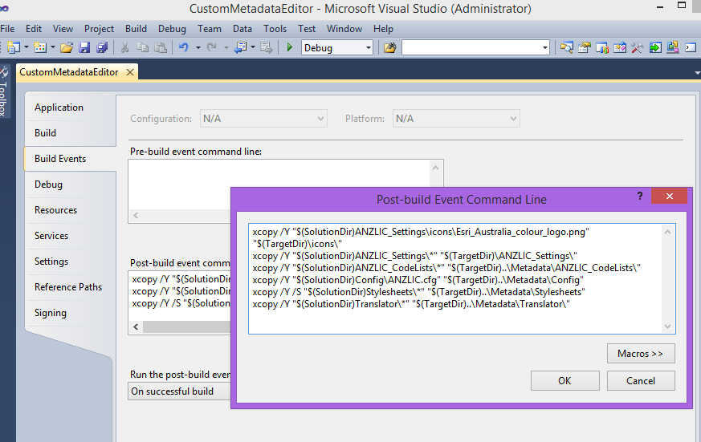

|  |  |
| --- | --- |
| Ref Nr | Post Build Event |
| 1 |  |
| 1.1 | xcopy /Y "$(SolutionDir)ANZLIC_Settings\*" "$(TargetDir)\ANZLIC_Settings\" |
| 1.2 | + |
|  |  |
| 2.1 | xcopy /Y "$(SolutionDir)ANZLIC_CodeLists\*" "$(TargetDir)..\Metadata\ANZLIC_CodeLists\" |
| 2.2 | xcopy /Y "$(SolutionDir)Config\ANZLIC.cfg" "$(TargetDir)..\Metadata\Config" |
| 2.3 | xcopy /Y /S "$(SolutionDir)Stylesheets\*" "$(TargetDir)..\Metadata\Stylesheets" |
| 2.4 | Included in 2.3 |
| 2.5 | Included in 2.3 |
| 3 | xcopy /Y "$(SolutionDir)Translator\*" "$(TargetDir)..\Metadata\Translator\" |
| 3.1 | Included in 3 |
| 3.2 | Included in 3 |

$(TargetDir) = C:\Program Files (x86)\ArcGIS\Desktop10.2\bin

$(SolutionDir) = C:\_Work\Development\ANZLIC\ArcGIS Metadata Toolkit 10_2_2\Visual Studio solutions\ANZLICMetadataEditor Source

Xcopy source destination

xcopy "C:\_Work\Development\ANZLIC\ArcGIS Metadata Toolkit 10_2_2\Visual Studio solutions\ANZLICMetadataEditor Source\Config\ANZLIC.cfg" "C:\Program Files (x86)\ArcGIS\Desktop10.2\Metadata\Config"

xcopy "C:\_Work\Development\ANZLIC\ArcGIS Metadata Toolkit 10_2_2\Visual Studio solutions\ANZLICMetadataEditor Source\Config\ANZLIC.cfg" "C:\Program Files (x86)\ArcGIS\Desktop10.2\Metadata\Config"

The /Q stops the names of the copied files from being written to the output window

The /Y stops it prompting you if it needs to overwrite a file

Sample

xcopy /Y “C:\Program Files (x86)\ArcGIS\Desktop10.2\Metadata\Config\ANZLIC.cfg” “C:\_Work\Development\ANZLIC\ArcGIS Metadata Toolkit 10_2_2\Visual Studio solutions\ANZLICMetadataEditor Source\Config\ANZLIC.cfg”

xcopy /Y "C:\_Work\Development\ANZLIC\ArcGIS Metadata Toolkit 10_2_2\Visual Studio solutions\ANZLICMetadataEditor Source\ANZLIC_CodeLists\*" "C:\Program Files (x86)\ArcGIS\Desktop10.2\bin\..\Metadata\ANZLIC_CodeLists"